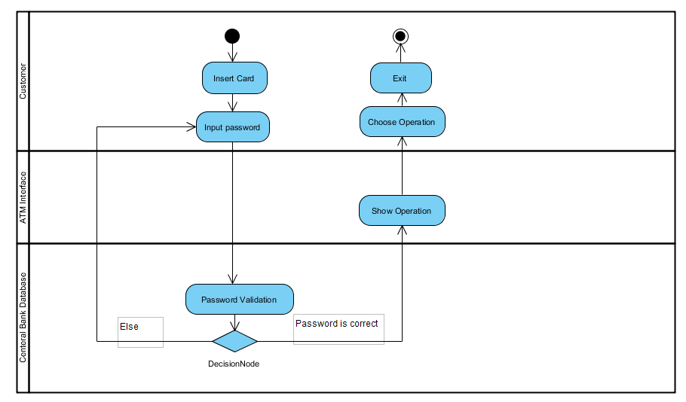

Figure 1 : The whole design for Activity Diagram

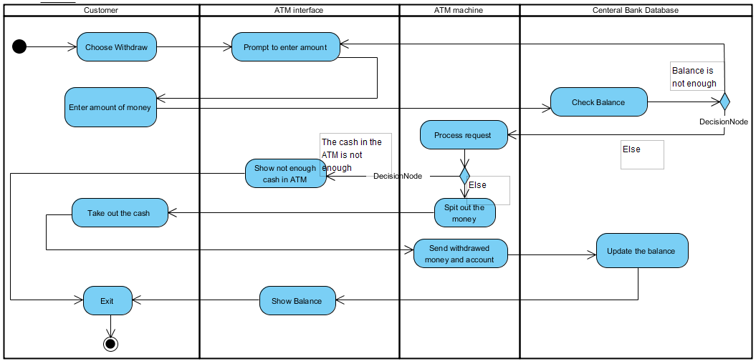

Figure 2 : The Activity Diagram for withdraw

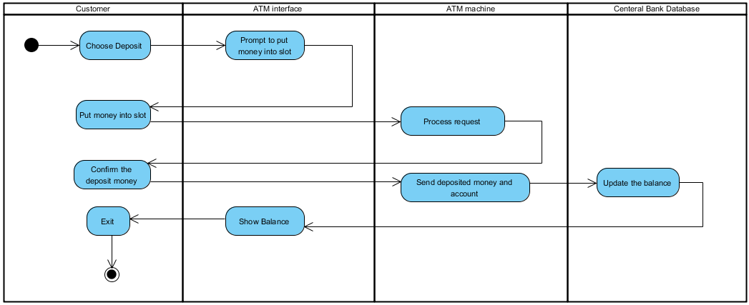

Figure 3 : The Activity Diagram for Deposit

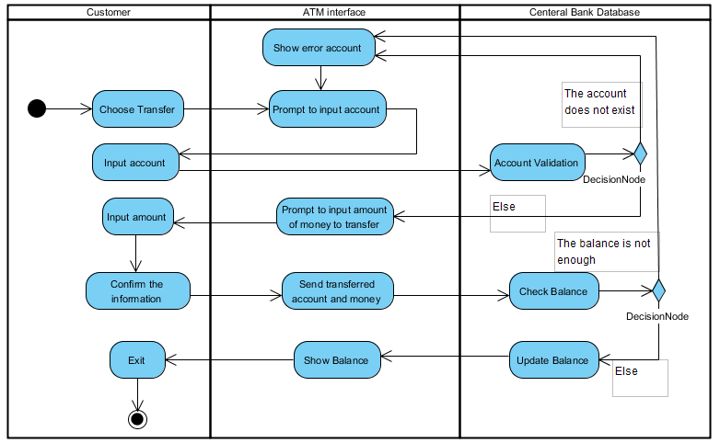

Figure 4: The Activity Diagram for Transfer

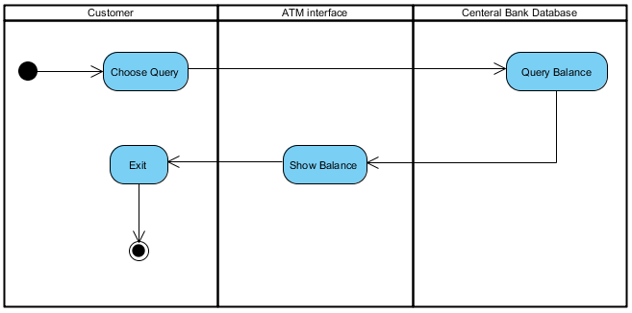

Figure 5 : The Activity Diagram for Query